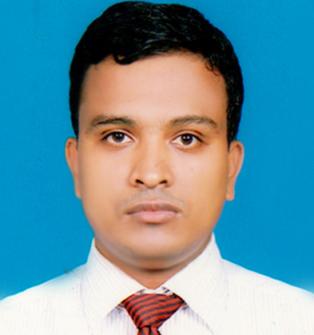

**“CURRICULAM VITAE”**

**Mailing Address:**

**Md. Salim Miah**

**317/2, Eastgoran, Khilgaon, Dhaka.**

**E-mail:** [**salim.nezom@gmail.com**](mailto:salim.nezom@gmail.com)

**Mob. – 01920444411,01620444411**

**Career Objective**

**To contribute in an organization where I can integrate my knowledge and skills to add value to that organization and explore my potentials.**

**Self-Assessment**

**I assume myself as a dynamic fellow of any challenging job provided to marketing professional. I always want to see myself in hard labor with enthusiasm. I am self-motivated and committed to my responsibilities.**

**Experience**

|  |  |  |
| --- | --- | --- |
| **Name of Organization** | **Post** | **Working Tenure** |
| **Dutch Bangla Bank Ltd.** | **Senior Sales Manager (Agent Banking)** | **(08.06.2016 to Continue )** |
| **Progati System Ltd.(Surecash Bd.)** | **Territory Manager** | **(24.02.2016 to 12.05.2016)** |
| **Mercantila Bank Limited** | **Territory Manager (Mobile Banking division(Rajshahi Branch)** | **(06.03.2014 to 28.02.2016)** |
| **Abul Khair Group** | **Territory Sales Incharge** | **(18.08.2013 to 25.02.2014)** |

**Educational History**

* **MBA**

**Name of Institution : Jagannath University**

**Area of Study : Business Administration**

**Concentration : Management**

**Results : 3.18 on a scale of 4.00**

**Year of Completion : 2010**

* **BBS**

**Name of Institution : Jagannath University**

**Area of Study : Business Administration**

**Concentration : Management**

**Results : Second Class**

**Year of Completion : 2008**

* **Higher Secondary Certificate**

**Name of Institution : Victoria Govt. College, Comilla**

**Area of Study : Business Studies**

**Result : 4.30 out of 5**

**Name of Board : Comilla Board**

**Year of Completion : 2004**

* **Secondary School Certificate**

**Name of Institution : Homna Govt. High School**

**Area of Study : Business Studies**

**Result : 3.63 out of 5**

**Name of Board : Comilla Board**

**Year of Completion : 2002**

**Personal Details**

* **Name : Md. Salim Miah**
* **Father’s Name : Abul Kasham**
* **Mother’s Name : Hasara Begum**
* **Permanent Address : Vill: Vobanipur, PO+PS: Homna, Dist: Comilla**
* **Date of Birth : 10 October, 1986**
* **Nationality : Bangladeshi by birth**
* **Marital Status : Single**
* **Height : 5.6”**
* **Blood Group : O+**

**Participation**

**Training (certificate course) Attended On:**

* **Basic Training on Mobile banking & Agent Banking Service:**

**Organized By: Dutch Bangla Bank Ltd.(FID Division)**

**Duration: 07 Days**

* **Basic Training on Mobile banking Service:**

**Organized By: Mercantile Bank Training Institute**

**Duration: 02 Days**

* **Marketing Management and Sales Promotion:**

**Organized By: Abul khair Group**

**Duration: One Week**

**Extra-curricular Activities**

* **Sponsor collection for social activities, event arrangement, helping ailing persons.**

**Computer Literacy**

* **Operating System: Windows 7 Ultimate Windows 2000/NT/2000xp**
* **Application Package: MS-Word, MS-Excel, MS-PowerPoint, Internet Browsing.**

**Language Proficiency**

* **Bengali : Mother Tongue**
* **English : Well versed in both written and spoken English.**
* **Hindi : Can understand only.**

**Reference**

|  |  |
| --- | --- |
| 1. **Md. Ahsan saleh Noor**   **Reginal Manager**  **Dutch Bangla Bank Limited**  **Chittagong Region.**  **Cell:01711505879** | **2. Md. Nazmul Islam**  **AVP & Reginal Manager**  **Dutch Bangla Bank Limited**  **Chittagong Region.**  **Cell:01713147587** |
|  |  |

**Declaration Of Authenticity**

**All the information I have provided is true to my knowledge and I will be able to submit required documents.**



**(Md. Salim Miah)**